The Determinants of Demand
For each question, describe which of the determinants of demand is being discussed. Then on the graph(s) show how the situation is likely to change demand and/or quantity demanded. Don’t forget to label EVERYTHING.
- Brenda gets a promotion and a raise. What is likely to happen to her demand for Starbucks coffee? What about her demand for Kroger Brand Coffee?

- Publix has a sale on Aunt Jemima pancake mix. The price of syrup remains unchanged.

- The Atlanta Journal Constitution reports that the population of Atlanta has increased by 5% this year. The New York Times reports that the population of New York City actually decreased by 5%. Jamil who has a Honda car dealership in both cities wonders how this will affect him.

Each question shows either a change in demand and/or a change in quantity demanded. For each question, create a scenario using the indicated determinant of demand that would cause that indicated change. Also add any information to the graph that is missing. Don’t forget to label EVERYTHING.

- Substitute Goods
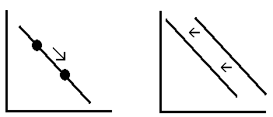

- Tastes and Preferences 6) Expectation of Future Prices
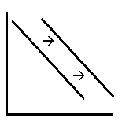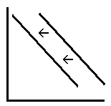

- Availability of Credit 8) ?????
